STAT 4318
Homework #2
Jorge Mendez

Problem 1
PROC IMPORT DATAFILE="/home/u64433614/Data/studentswithvarnames.xlsx"
OUT=work.class
DBMS=xlsx REPLACE;
GETNAMES=YES;
RUN;
PROC CONTENTS DATA=work.class VARNUM;
RUN;
PROC PRINT DATA=work.class;
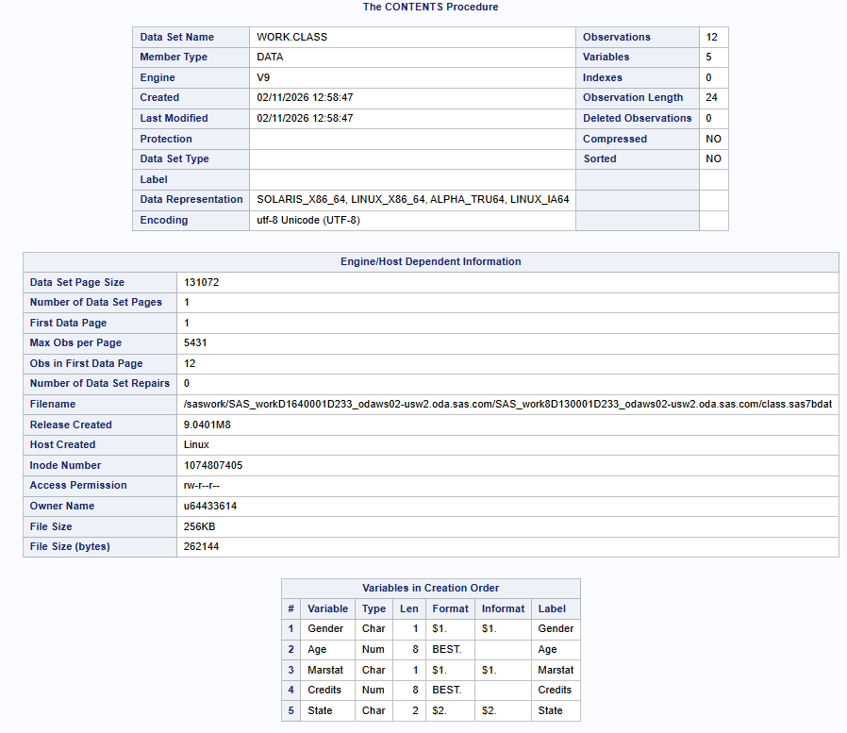
RUN;

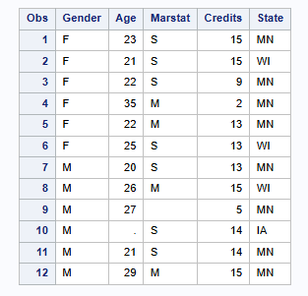

Problem 2

DATA WORK.BP1;

INFILE "/home/u64433614/Data/bp.txt"
DLM='09'X
DSD
FIRSTOBS=2
TRUNCOVER;

LENGTH PTID $20 CLINIC $20 SEX $1;

INPUT
PTID $
CLINIC $
AGE
SEX $
DBPBL
DBP6
DBP12
SBPBL
SBP6
SBP12
;
RUN;
PROC CONTENTS DATA=WORK.BP1 VARNUM;
RUN;
PROC PRINT DATA=WORK.BP1 (OBS=10);
RUN;
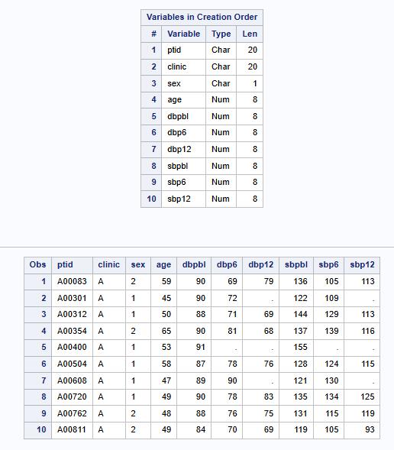
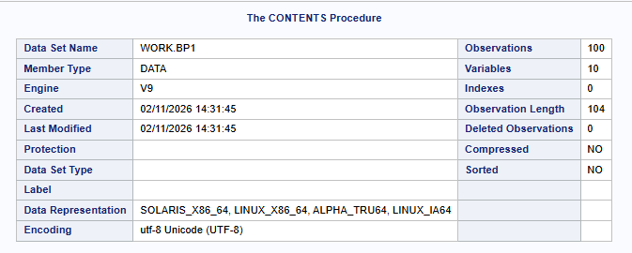

PROC IMPORT DATAFILE="/home/u64433614/Data/bp.txt"
OUT=WORK.BP2
DBMS=TAB
REPLACE;
GETNAMES=YES;
RUN;

PROC CONTENTS DATA=WORK.BP2 VARNUM;
RUN;

PROC PRINT DATA=WORK.BP2 (OBS=10);
RUN;
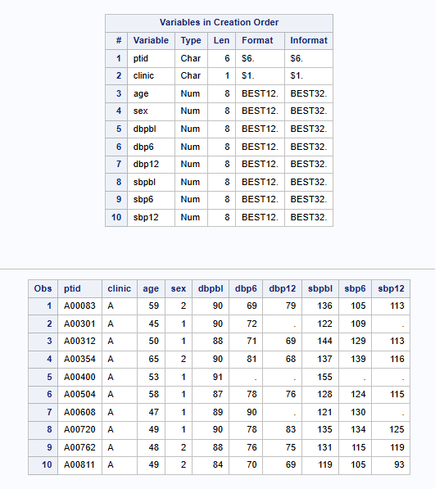

Italics Answer: The length of the variable CLINIC in dataset BP1 is 20, while in dataset BP2 it is 1. The difference occurs because BP1 was created using a DATA step where the length was manually specified, whereas BP2 was created using
Problem 3

DATA work.tomhs_subset;

INFILE "/home/u64433614/Data/tomhs.dat" LRECL=200 TRUNCOVER;

LENGTH ptid $6 clinic $1;

INPUT
@1 ptid $CHAR6.
@12 clinic $CHAR1.
@25 group 1.
@27 age 2.
@30 sex 1.
;

RUN;

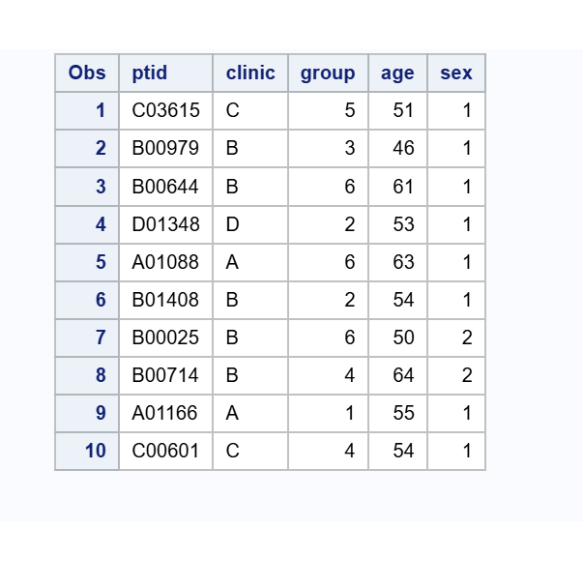

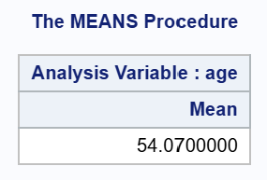
Italics answer: The mean is 54.07

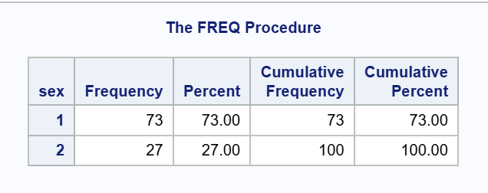
Italics answer: There are 73 men and 27 women

